**BC Web Wise creates the first ever Skin Stress Tool for Bajaj Nomarks**

**Mumbai, 17th July 2018:** BC Web Wise, one of India’s oldest and most renowned digital marketing agency, notable for its extensive digital marketing expertise, has created the first ever AI-technology driven Skin Stress Tool for Bajaj Nomarks, in a [website](https://www.bajajnomarks.com/) that delivers the skin-stress message at a glance, creating user interest and interaction to know more.



**Bajaj Nomarks – Skin Stress Tool**Bajaj Nomarks Skin Stress Tool is a way to understand how stressed an individual’s skin is basis skin type, sun exposure, water intake, and sleep duration. While similar tools have been created by skin care brands in the past, this tool is unique in its experience. It does not need the user to scan their face, take a litmus test, or press a tissue paper to their face. It communicates through the Artificial Intelligence (AI) bot, Noma, that resides on the freshly revamped Bajaj Nomarks [website](http://www.bajajnomarks.com/).



Through an interactive journey with the user, Noma scans through the interaction and using AI reveals a Skin Stress Meter Score, as well as gives the user the root-cause the skin stress. It also provides a customised skin care regime for the user to address the problem

The [tool](https://youtu.be/wyE8LDiNgBo) will be promoted through various digital platforms like social, search and content distribution networks.

[Screengrab video of the Noma, attached]

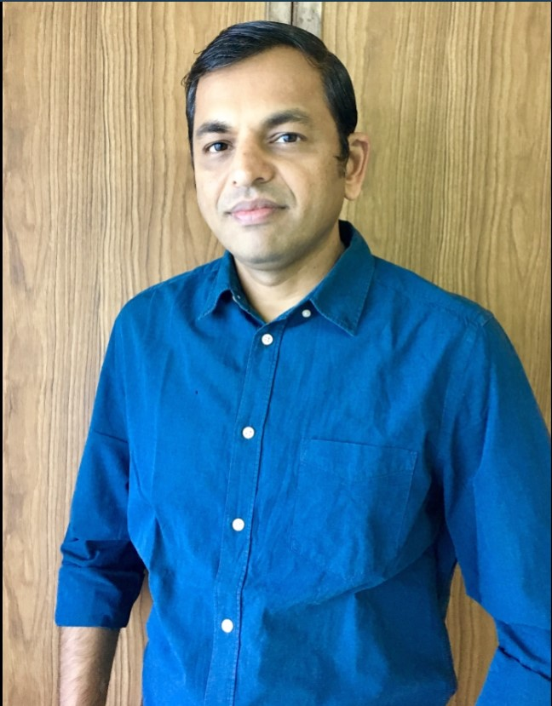  
Sandeep Verma, President Sales and Marketing, Bajaj Nomarks, says, “Our endeavour is to connect with this audience in a differentiated manner. So we decided to restage NOMARKS as a modern Ayurvedic brand. New packaging was a key element of the mix to strongly communicate this change. In addition we have launched a campaign based on how a polluted environment combined with a demanding lifestyle results in skin stress, which manifests itself in the form of marks. The Skin Stress Tool, Noma, is a very innovative use of AI to build the concept of skin stress and build credibility for the brand



Adds, Chaaya Bharadwaaj, Founder and MD, BC Web Wise, “The brand has a very focused proposition, unique to it, focusing on the stress that our skin goes through, and which causes various problems. However, we as an audience, don’t really understand the implications of skin stress and what causes it. Digital interactions reveal a lot of information about our customer. This gave birth to leveraging AI. Further we also have seen that the simpler it gets the more is the user adaptation and that’s really what this tool does.”

You can find a solution to your skin stress, [here](http://www.bajajnomarks.com/).

**About BC Web Wise**

BC Web Wise is a full-service digital marketing agency renowned for its strategic brand services, world-class creative work, and in-depth consumer research. Founded by Chaaya Baradhwaaj in 2000, the agency has a presence in Mumbai and Delhi. It is amongst the few independent digital agencies in India with a vast and reputed client portfolio including Hero MotoCorp, Kokuyo Camlin, Axis Bank, Abbott, Hindustan Unilever, Aditya Birla Capital, JK Lakshmi Cement, ICICI Prudential, and Bajaj Consumer Products amongst several others. The agency’s integrated digital solutions range from video production, website development, search marketing, media planning and buying, social media marketing, online reputation management, e-commerce web design and development, search marketing, performance marketing and mobile app development.

BC Web Wise has a history of doing innovations and being first movers in adapting new and latest digital technologies, and bringing global firsts to the table for its clients Few of the award-winning innovations for its brands. Gang of Girls for Sunsilk – a community for girls; Movekars for Aditya Birla Health – a Progressive Web App that helps the audience workout in their daily routine; Experience App for Camlin – a virtual canvas to try the entire Camlin product range, the texture and finish of each; Keratinology for Sunsilk - a virtual hair studio; BC Web Wise has mothered it all and more.

**About Bajaj Nomarks**

Bajaj Corp Ltd. is one of the leading players in the Hair Oil category with brands like Bajaj Almond Drops Hair Oil, Bajaj Brahmi Amla Hair Oil, Bajaj Amla Hair Oil and Bajaj Jasmine Hair Oil.

Apart from hair oils, Bajaj Corp Ltd. has presence in the Skin Care category with the Nomarks range of products. Bajaj Nomarks Cream was the first ever anti-marks cream in India and is completely Ayurvedic in its formulation. Bajaj Nomarks also has a facewash, scrub and a face pack to take care of your facial marks. The vision of the company is to harness its heritage of 90 years and combine it with leading edge scientific knowledge to bring innovative, high quality products for consumers across the world to help them get more out of life.

**For further information, please contact:**

**Name:** Pamela Correa

**Email ID:** pamela.correa@bcwebwise.com

**Contact No.:** +91 9820611395